**Tharun Bejawada (191911509)**

**USING RAPTOR – CHECK GIVEN NUMBER PRIME OR NOT**

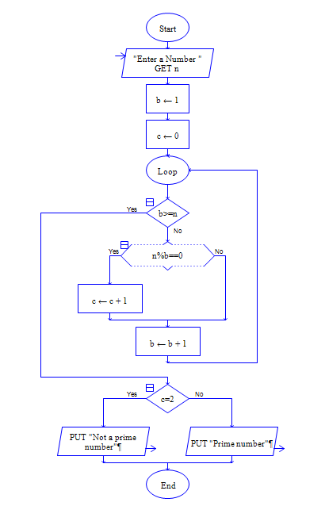

**OUTPUT**

INPUT IS 5

